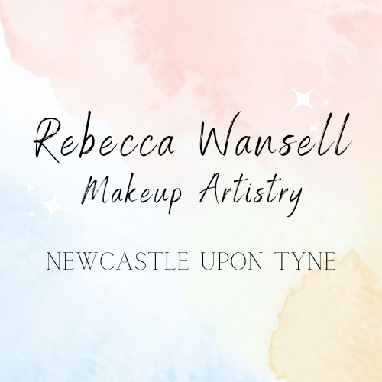

Terms & Conditions

- As A Client
To make sure all clients have the best possible experience, we have a few standard terms and conditions.
1.1 Cancellation Policy
While we know life can throw unexpected issues your way, we like to think of ourselves as fair and reasonable, which is why we ask for at least a 48-hour notice for all cancellations. Less than 48-hours requires the full bill to be paid.
Bridal & occasion makeup bookings are non-refundable and non-transferable, this also includes any trials. Deposits are non-refundable.
We reserve the right to cancel your appointment without notice due to circumstances beyond our control, such as illness or injury. We will endeavour to find a replacement makeup artist for you, if there is less than 48 hours notice. If a cancellation is made on our behalf due to circumstances beyond our control, you will be refunded in full.
  - Late Arrivals
If you are late for your appointment, it may interfere with your treatment time. All appointments will end at their scheduled time and treatments may be altered to ensure the next client will not be delayed. Full payment is still required.
1.3 Payment
Payment is accepted by cash or bank transfer. Bank transfers must be made before or during your appointment and not after.
1.4 Patch Testing
Patch testing is required at least 24 hours before your appointment. Let us know immediately if you have any reactions to your patch test.
The eyelash glue used for false eyelashes contains latex, therefore it is not suitable for clients with latex allergies.
1.5 Offers
Offers on the website, or on social media channels, are for the defined date only. Once the offer period has ended the treatments will revert to their normal price.
1.6 Complaints Procedure
We care very much about ensuring all our clients leave their appointments feeling content. If there’s any reason you feel unhappy with a treatment or service, you are entitled to raise a complaint. If you have a grievance at your appointment, you must let us know so we can deal with it appropriately on the day. If this is not possible, an email must be sent within 24 hours including photographic evidence. When raising a complaint, you may be required to attend an appointment to provide evidence. We do not take complaints via social media and you will be directed to email. Payments will not be refunded for treatments without following the complaints procedure and providing evidence. Refunds are at the discretion of the company.
1.7 Price Alteration
We reserve the right to alter prices without prior notice.
1.8 Data Protection
Personal details taken from clients are kept safe and confidential. For full details please read the Privacy Policy found on at rebeccawansellmakeup.co.uk.
1.9 Smoking and Drinking
We will not perform any mobile treatments while clients smoke or vape any substances or consume any alcohol. Please wait until after. I cannot perform any treatments on any clients that are under the influence or drugs and alcohol. You will not be refunded If your treatment cannot go ahead due to smoking and drinking.
There is the exception of light alcohol drinking such as prosecco and champagne on the day of your wedding.
1.10 Medical Conditions and Health
Please inform us immediately of any medical conditions or health issues, including pregnancy, prior to your booking as some treatments may not be appropriate for you. When we arrive for your treatment you will be asked about your medical history. Existing clients are required to inform us of any changes between appointments.
1.11 Children
Due to our insurance, we cannot accommodate children under 18 years of age unless their parent/guardian is present at all times and has provided consent.
1.12 Personal Items
We cannot be held responsible for personal belongings which are lost or damaged. It is your responsibility to ensure personal items are safely stored during your treatment.
1.13 Covid-19
We cannot be held responsible for any cancellations or changes to bookings on our part as a result of Covid-19 infection, self-isolation or illness from Covid. Where reasonably possible we will always endeavour to seek a replacement makeup artist.
If a client needs to self-isolate due to Covid-19 infection, you must contact us immediately. We will try our best to make changes to appointments, however this may not always be possible due to clashing with other bookings. We cannot refund deposits in this instance, we can offer a voucher of the amount paid to be used within 2 years.

